**BUS BOOKING FORM**

**Html code for bus booking**

**<html>**

**<head>**

**<script type="text/javascript" >**

**function validate()**

**{**

**if( document.Busbooking.textname.value == "" )**

**{**

**alert( "Please provide your Name!" );**

**document.Busbooking.textnames.focus() ;**

**return false;**

**}**

**if( document.Busbooking.textFathername.value == "" )**

**{**

**alert( "Please provide your Father Name!" );**

**document.Busbooking.fathername.focus() ;**

**return false;**

**}**

**if( document.Busbooking.busname.value == "" )**

**{**

**alert( "Please provide busname!" );**

**document.Busbooking.busname.focus() ;**

**return false;**

**}**

**if( document.Busbooking.bustime.value == "" )**

**{**

**alert (“Please provide bustime!”);**

**document. Busbooking.bustime. focus ();**

**return false;**

**}**

**if( document.Busbooking.seatno.value == "" )**

**{**

**alert( "Please provide seatno!" );**

**document. Busbooking.seatno.focus();**

**return false;**

**}**

**if( document.Busbooking.from.value == "-1" )**

**{**

**alert( "Please provide from!" );**

**document.Busbooking.from.focus () ;**

**return false;**

**}**

**if( document.Busbooking.to.value == "-1" )**

**{**

**alert (“Please provide to!" );**

**document.Busbooking.to.focus() ;**

**return false;**

**}**

**if ( (Busbooking.gender[0].checked == false ) && (Busbooking.gender[1].checked == false ) )**

**{**

**alert ( "Please choose your Gender: Male or Female" );**

**return false;**

**}**

**if( document.Busbooking.MobileNo.value == "" ||**

**isNaN( document.Busbooking.MobileNo.value) ||**

**document.Busbooking.MobileNo.value.length != 10 )**

**{**

**alert( "Please provide a Mobile No in the format 123." );**

**document.Busbooking.mobileno.focus() ;**

**return false;**

**}**

**else**

**alert("successful Busbooking");**

**return( true );**

**}**

**</script>**

**</head>**

**<body>**

**<form action="#" method ="post" name="Busbooking" onSubmit="return validate()">**

**<table cellpadding="2" width="20%" bgcolor="99FFFF" align="center">**

**<tr>**

**<td colspan=2>**

**<center>**

**<font size=4><b>Busbooking form</b></font></center>**

**</td>**

**</tr>**

**<tr>**

**<td>Name</td>**

**<td><input type="text" name="textname" id="textname" size="30"></td>**

**</tr>**

**<tr>**

**<td>Fathername</td>**

**<td><input type="text" name="textFathername" id="textFathername" size="30"></td>**

**</tr>**

**<tr>**

**<td>busname</td>**

**<td><input type="text" name="busname" id="busname" size="30"></td>**

**</tr>**

**<td>bustime</td>**

**<td><input type="text" name="bustime" id="bustime" size="30"></td>**

**</tr>**

**<td>seatno</td>**

**<td><input type="text" name="seatno" id="seatno" size="30"></td>**

**</tr>**

**<tr>**

**<td>from:</td>**

**<td><select name="from">**

**<option value="-1" selected>select..</option>>**

**<option value="sorab">sorab</option>**

**<option value="sagara">sagara</option>**

**<option value="shiralkoppa">shiralkoppa</option>**

**<option value="shikaripura">shikaripura</option>**

**</select>**

**</td>**

**</tr>**

**<tr>**

**<td>to:</td>**

**<td><select name="to">**

**<option value="-1" selected>select..</option>**

**<option value="mysore">mysore</option>**

**<option value="mandya">mandya</option>**

**<option value="hassan">hassan</option>**

**<option value="dharvad">dharvad</option>**

**<option value="ghadag">ghadag</option>**

**</select>**

**</td>**

**</tr>**

**<tr>**

**<td>Gender</td>**

**<td><input type="radio" name="gender" value="Male" size="10">Male**

**<input type="radio" name="gender" value="Female" size="10">Female</td>**

**</tr>**

**<tr>**

**<td>Mobile No</td>**

**<td><input type="text" name="MobileNo" id="MobileNo" size="30"></td>**

**</tr>**

**<tr>**

**<td><input type="Reset"></td>**

**<td colspan="2"><input type="submit" value="Submit form" /></td></tr>**

**</table>**

**</form>**

**</body>**

**</html>**

**OUTPUT:**

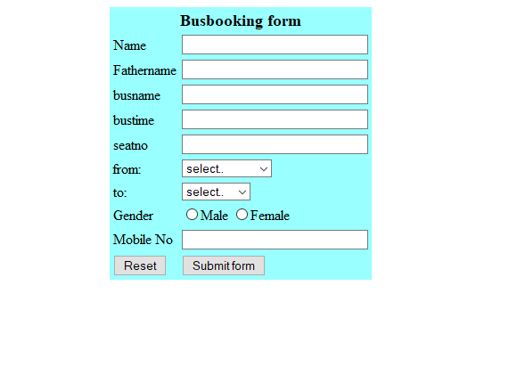

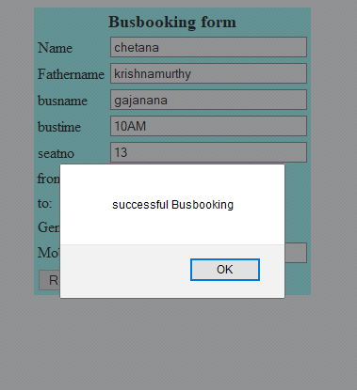

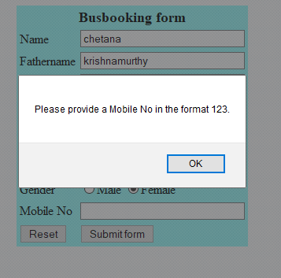

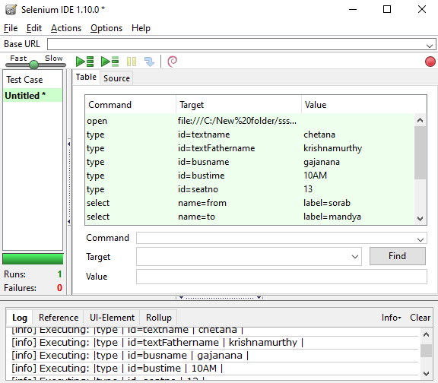

**Conduct a test suit for any two web sites.**

**Requirements:**

Download Selenium IDE 1.5 or above from http://seleniumhq.org/download/ from Firefox

browser.

Firefox version 10.0

Internet connection required.

**Google TestCase #1:**

• Go to tools and then click on Selenium IDE

• Click on record button in Selenium IDE

• Open Firefox Web Browser

• In the address bar, Type http://www.google.com

• Type “Selenium RC” in the Google Search Input Box

• Click outside on an empty spot

• Click Search Button

• Verify the Text Present as “Selenium RC”

• Assert the Title as “Selenium RC - Google Search”

• Save the test case with pgm2.HTML

**Yahoo TestCase#2:**

• File Open click new Test Suite

• Open Firefox Web Browser

• In the address bar, Type http://www.yahoo.com

• In the search input button, Type "energy efficient"

• Click on the "Web Search" submit button

• Wait for Search Results to come on "http:/search.yahoo.com"

• Verify "energy efficient" text is present anywhere in the search results:

• (Select and highlight anywhere in the search results page, "energy efficient" text is

present.)

• Verify the browsers title has the value "energy efficient - Yahoo! Search

Results"

• Save the test case with .HTML Extension.

• Run the test suite.

**OUTPUT:**

